Step 1 — Download the MongoDB MSI Installer
To begin the MongoDB installation process on your Windows system, please visit the official MongoDB website and https://www.mongodb.com/try/download/community the latest version of MongoDB.
Ensure that you choose the MSI package for downloading. This package is specifically designed for Windows installations and will provide a smooth installation experience.
Press enter or click to view image in full size

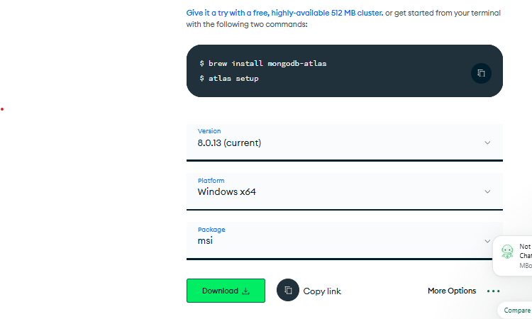

Step 2 — MongoDB Installation
Ensure that you are logged in to your Windows account with administrative privileges.
Once confirmed, proceed to the “Downloads” folder on your system and locate the recently downloaded .msi package.
Double-clicking on this file will initiate the installation wizard, which will guide you through the MongoDB installation process.
Click Next to start installation.
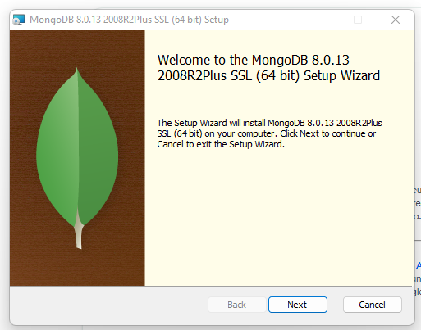

Accept the licence agreement then click Next.
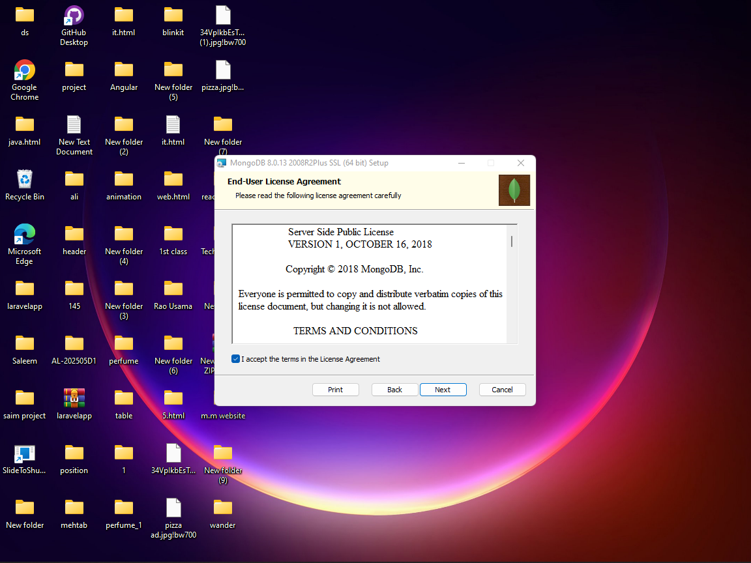
Select the Complete setup
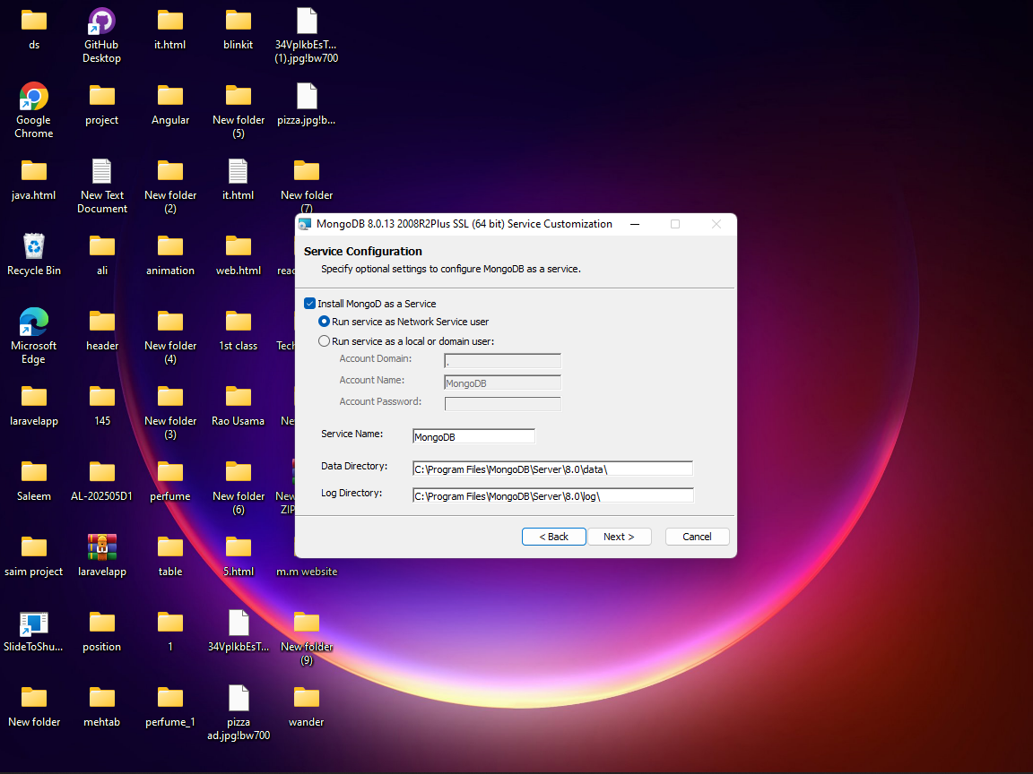

If you require Mongo Compass, select the checkbox next to it and proceed by clicking on the “Next” button.

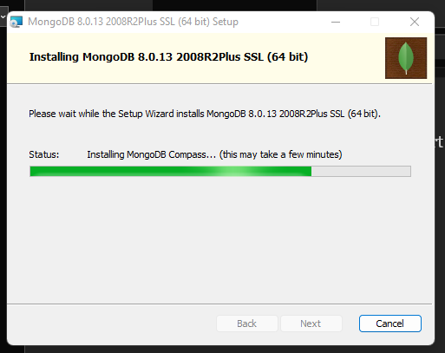

Click Next to begin installation.
Press enter or click to view image in full size
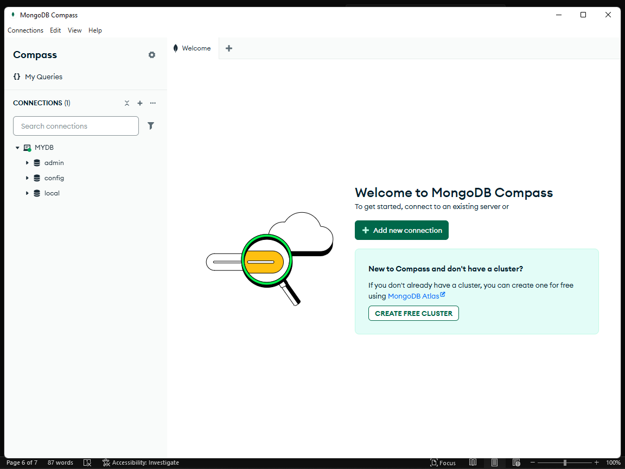

Now, Open the MongoDB Compass
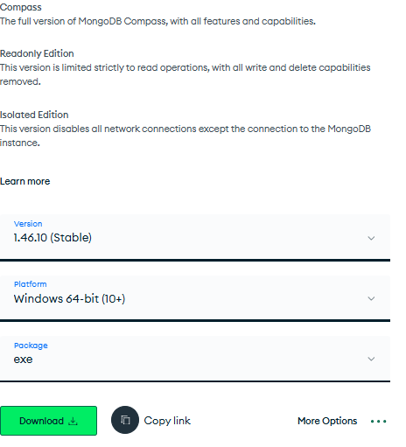

Then, Download the EXE Package .
For Adding MongoDB Atlas Cluster
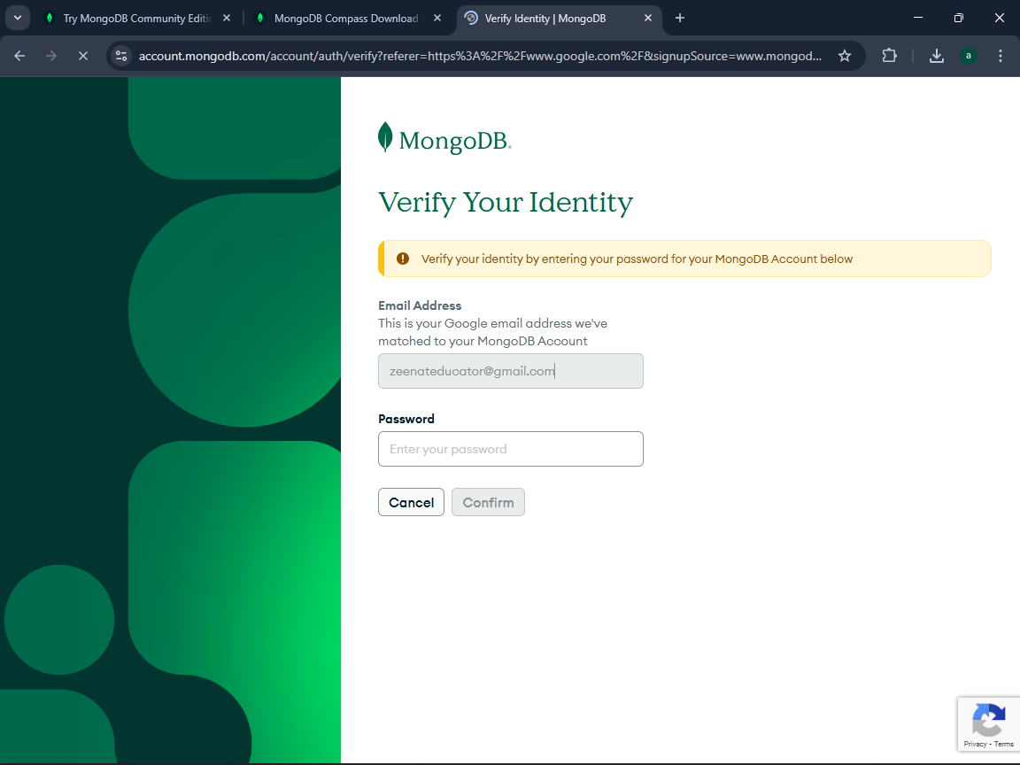

Verifying account using google credentials

